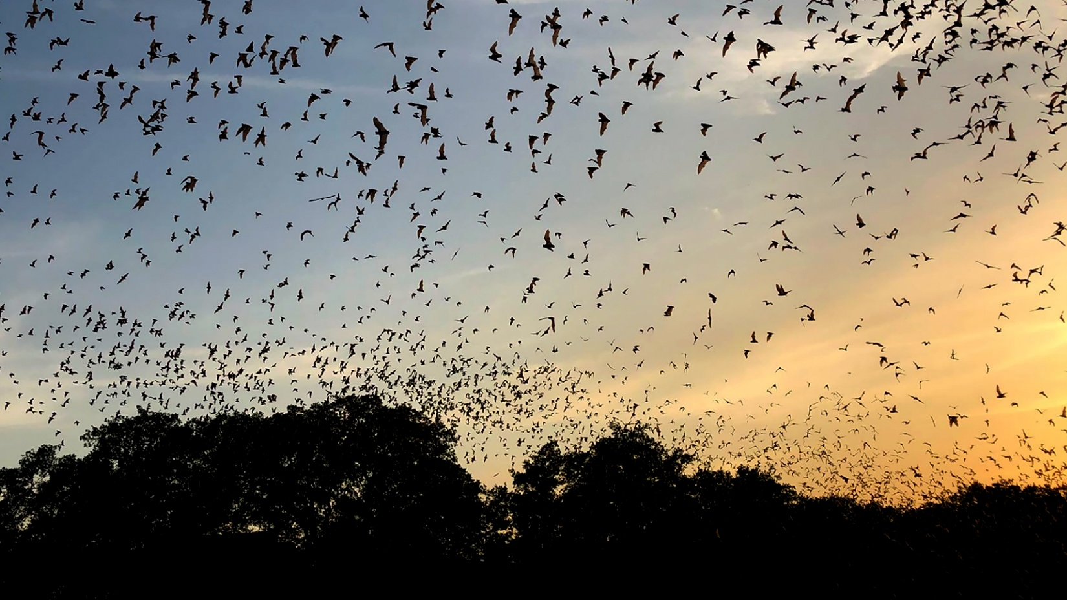
The Shrewsbury Conservation Commission is thrilled to invite you
to the Shrewsbury Library Friday, February 27th at 7:00pm
to view the spectacular screening of
The Invisible Mammal

This film will make you fall in love with bats!

